Yuyi Zhang
Oct 18, 2020
Fall 2020 CPS Quarter
Instructor: Dr. Steward Huang
Module 5:
Generalized Linear Regression & Logistic Regressions
ALY 6020_Predictive Analytics

Introduction
In this report, we are going to go through two datasets using Logistic regression. The logistic model belongs to generalized linear model family. For practicing, we are going to use the survival rats data set and adults data set.

Analysis

Survival Data Set
In this dataset, there are 100 out of 300 rats were treated with drug coming from 100 litters. We are going to use logistic regression to classify the event of tumor.

Step 1 – collecting data
Let’s import the adult data and take a look at the first six rows.
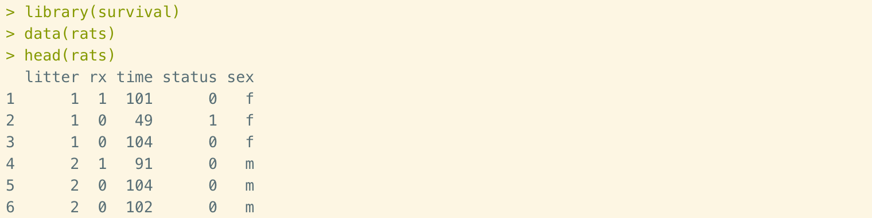
Figure 1. Importing data and first rows
There are 300 observations of 5 variables. Litter indicates the litter number from 1 to 100. There are 3 rats selected from each litter. And only 1 of them treated with drugs. Rx means treatment (1 = drug, 0 = control). Time indicates time to tumor, or last follow-up days. Status indicates whether or not having tumor (1 = tumor, 0 = censored).

Step 2 – fitB1
Employ logistic regression to the rats data and get the summary page.
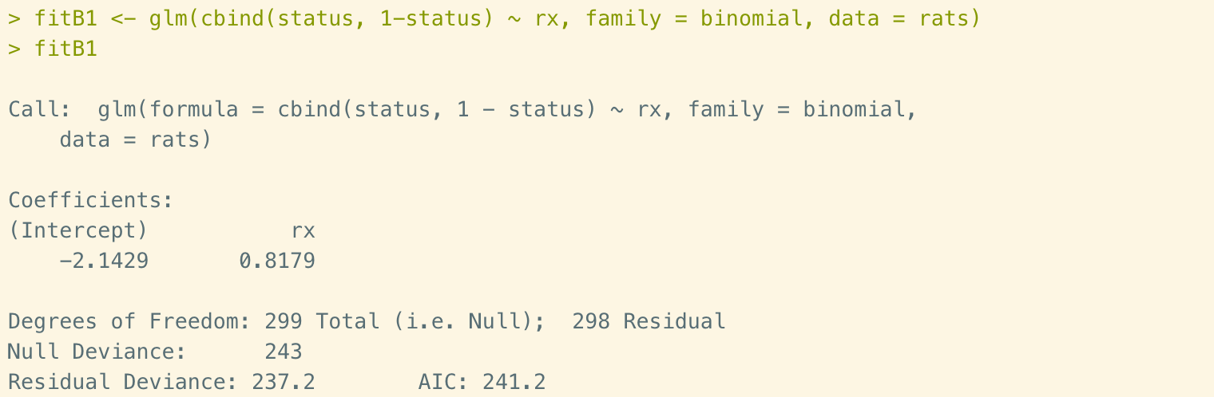
Figure 2. fitB1
In this formular, we are looking for coefficients between target feature (status) and drug treatment. The coefficient values are negative, indicating that these two features are negative corelated.
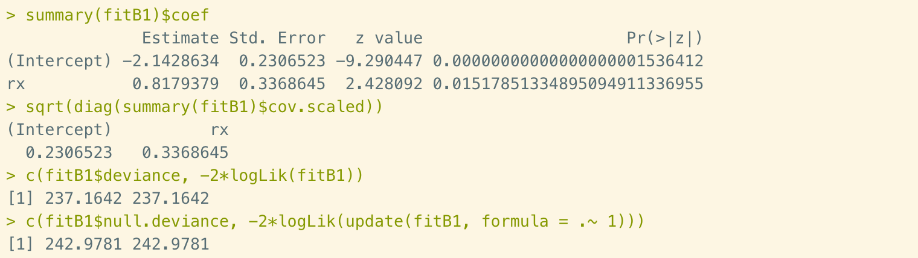
Figure 3. fitB1 evaluation
Standard errors could be catch up from the summary page, or the sqrt() function. It associated with the coefficients, that is used for testing whether the parameter is significantly different from 0. It could also be used to form a confidence interval for the parameter, as shown in the last two functions.

Step 3 – fitB2
In this step, we are going to use update() function to change the family of fitB1 in specified link.
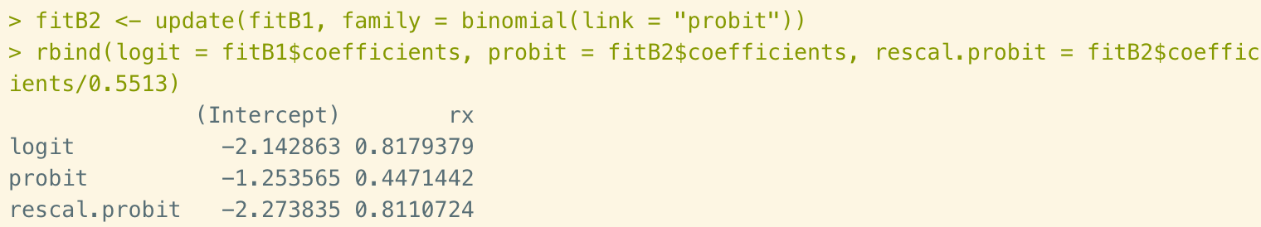
Figure 4. fitB2 vs. fitB1
In this part, we compare the coefficient value of Logistic model and Probit model. The intercept value of logit model is much higher than Probit, but lower than rescaled Probit model.

Step 4 – fitB3
In step 4, we are going to update fitB1 again by adding log(time).
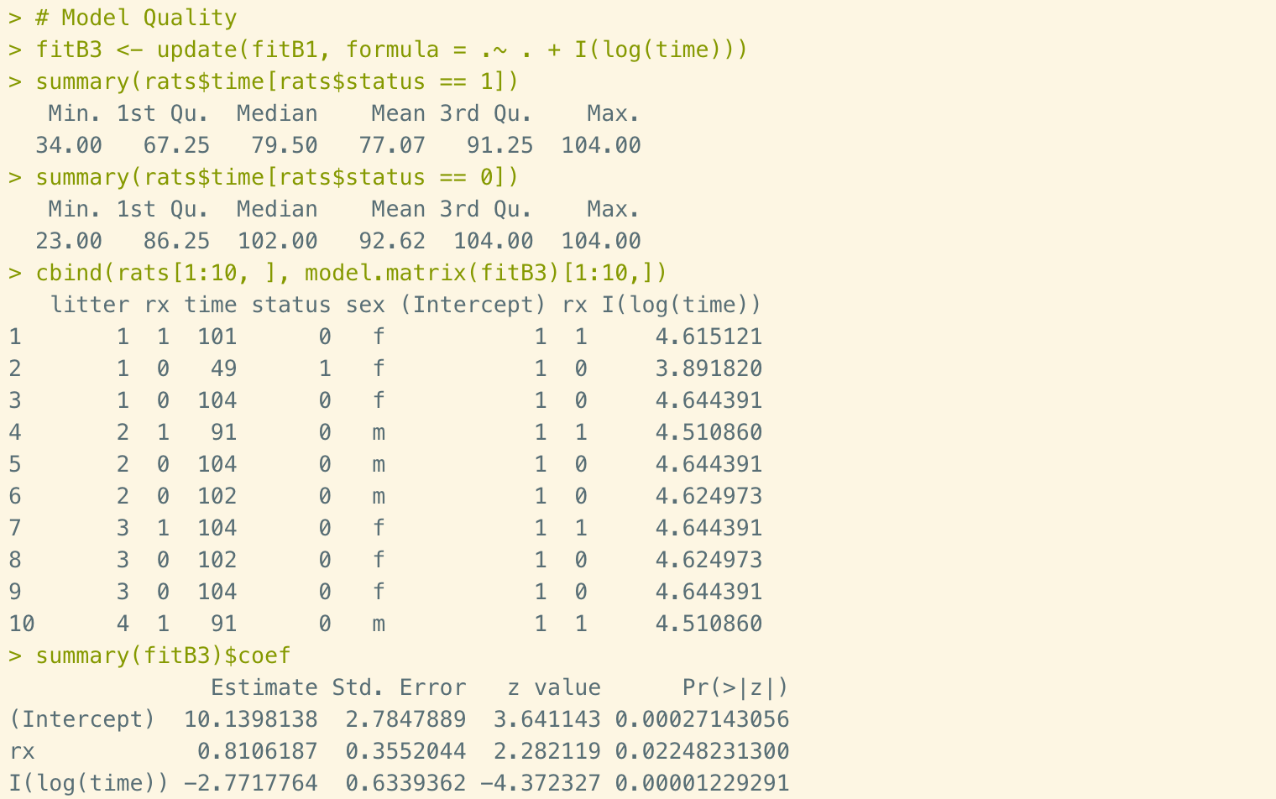
Figure 5. fitB3
As we can see that “time” is not bad idea of being a predictor, because the range of times don’t not change so dependently. The mean time of generating tumor is 77 days and time of not negating tumor is about 93 days. We could also see the coefficient value of log(time) is much higher than treatment.

Step 5 – fitB4
Because of the LRT value is still highly significant, so we still need to figure out some other additional terms to adjust the model.
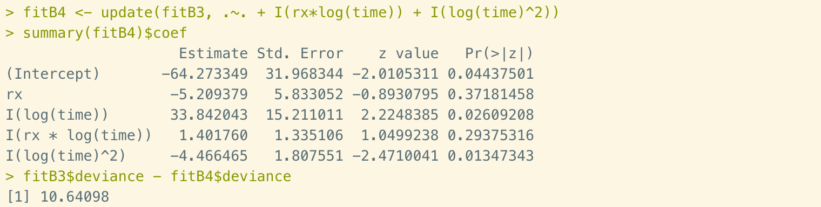
Figure 6. fitB4
This time we added rx*log(time) and log(time)^2 into model fitB3. All the new variables do not look significant showing from the coefficient matrix. We can also compare the deviance of all models at once.
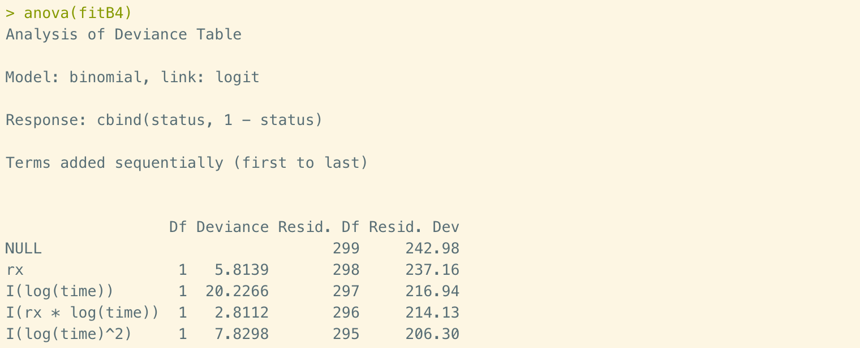
Figure 7. Anova table
The Anova table shows deviance values of all previous models.
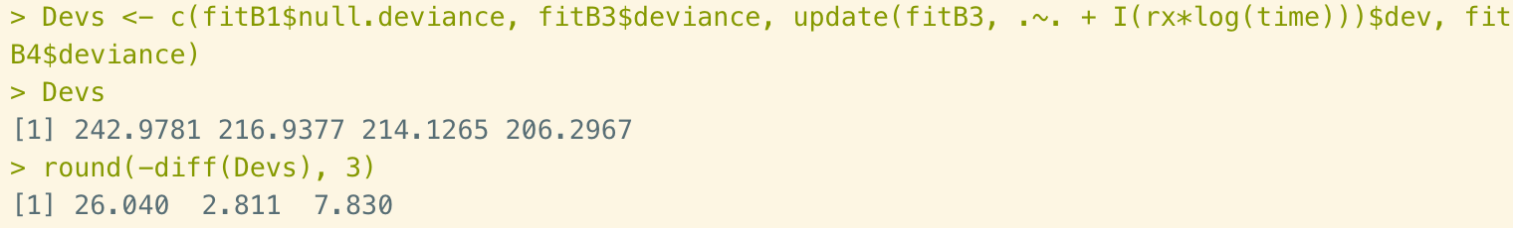
Figure 8. Deviance comparisons
Here’s the comparison table of deviance. We could see a decreasing trend from fitB1 to fitB4.

Adult Data Set
In this adult dataset, we are going to predict whether an individual adult will or will not have income above 50k.

Step 1 – collecting data
Let’s import the adult data and take a look at the first six rows.
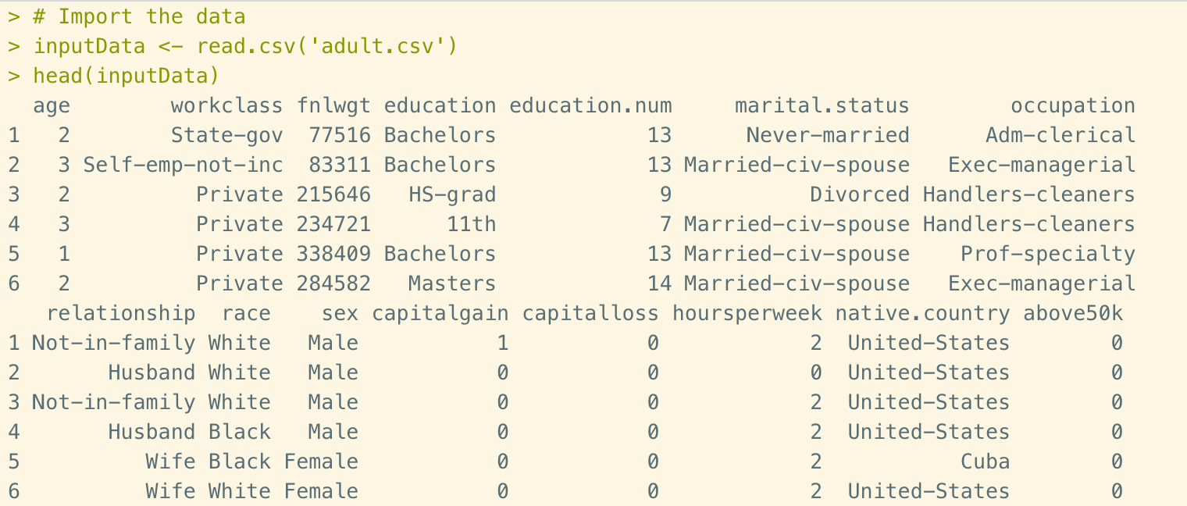
Figure 9. Importing data and first rows
There are 48,842 observations of 15 variables. It includes 14 different features of an adult and target feature is whether income is above 50K. 0 indicates no and 1 indicate yes. To classify the income of 50K, we are going to employ logistic regression to the data set.

Step 2 – Check Class Bias
Ideally, the portion of each event need to be the same. But in this case, we could see that the 0 event is much higher than 1. So next step we are going to solve this problem and split training and test data.
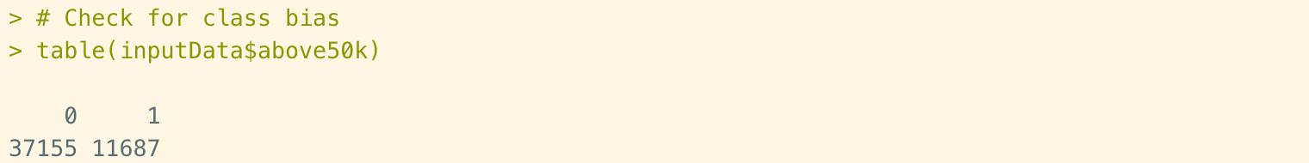
Figure 10. Check class bias

Step 3 – Create Training and Test Samples

Create Training Data
There’s the code for creating training data.
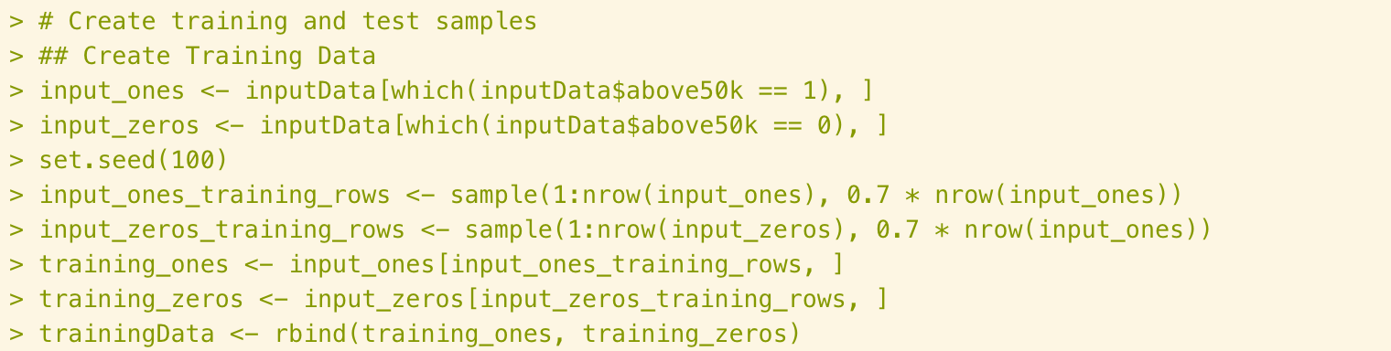
Figure 11. Create training data
First split the entire dataset into two factors according to 50K income level. As we know that input_ones has fewer rows. So we use the number of input_ones rows apply to both training dataset. Then we randomly select 70% data assigning to training data.

Create Test Data
The number of test data doesn’t require to be the same. So we could easily collect all the remaining data and combine to a test data set.
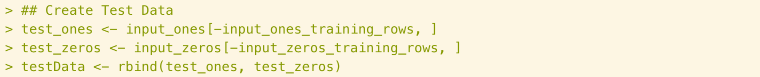
Figure 12. Create test data

Step 4 – Compute Information Values
First things first, create two factors of variables and create a data frame with all variables listed.
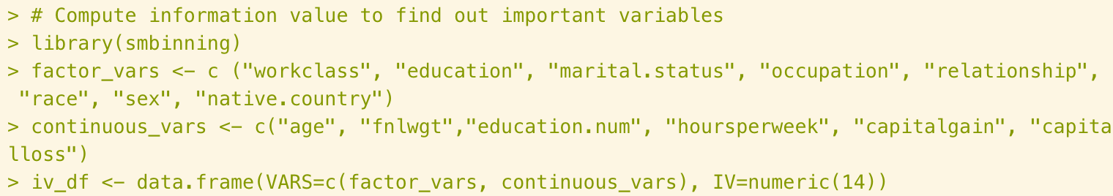
Figure 13. Segregate continuous and factor variables
Then compute information values for each variable.
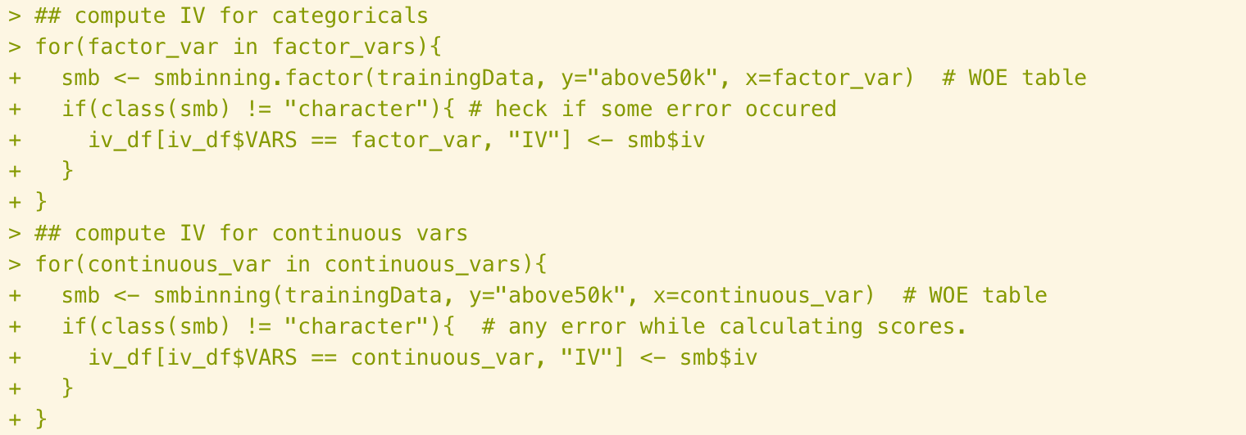
Figure 14. Compute IV for all variables
Then sort them decreasingly and print out.
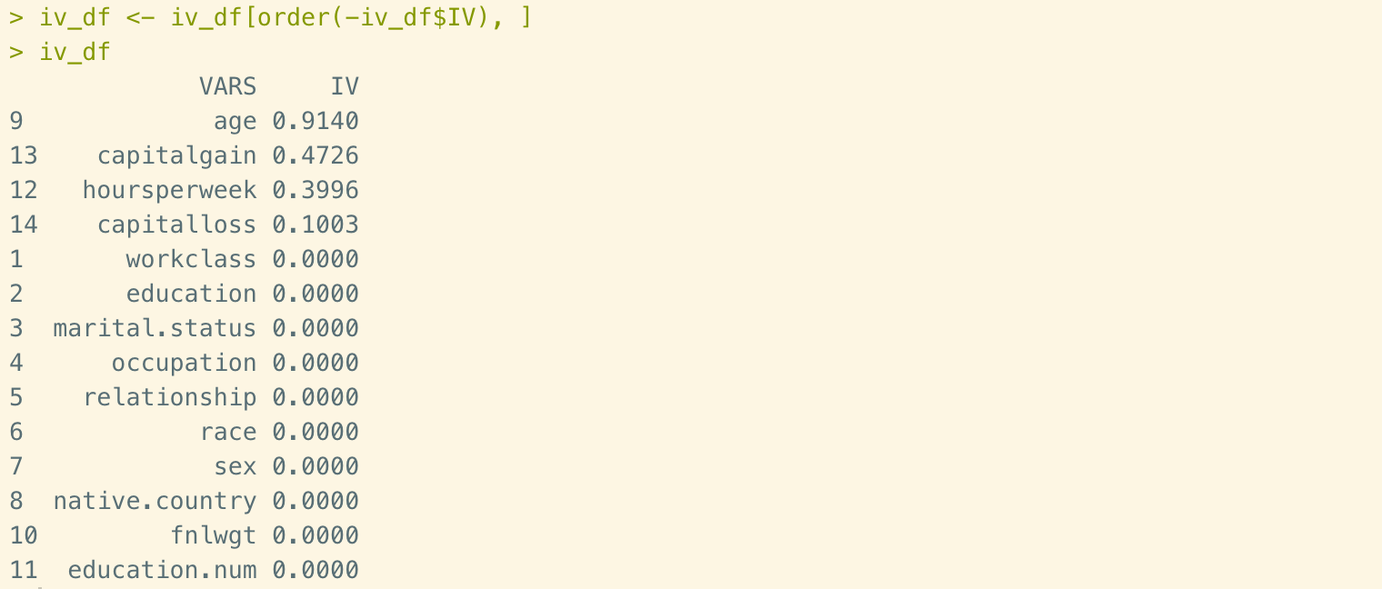
Figure 15. List of information value
From this result we could see that only 4 out of 14 variables have information values. This is to say that 4 of all 14 features would affect the result of income level.

Step 5 – Build Logit Models and Predict
After all the prepared work has been done, now we could employ the glm() function to training data and use the trained model to predict the test data.
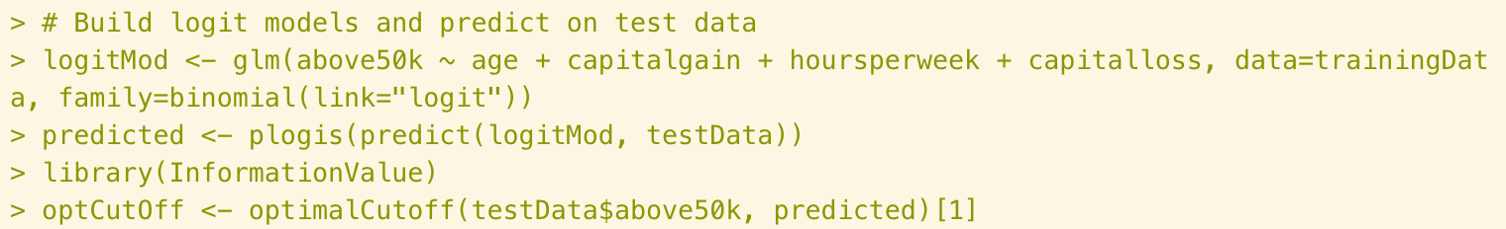
Figure 16. Build the model
One thing needs to be mentioned is the cutoff prediction probability score. The default value is 0.5. But in practice, tuning the probability cutoff would help to improve the performance. The InformationValue::optimalCutoff function is the way to find out the adjusted cutoff value. In this case, it is 0.89.

Step 6 – Model Diagnostics

Summary
The performance could be recognized and evaluate in many different ways. First we could use summary() function to get a general idea of diagnostics.
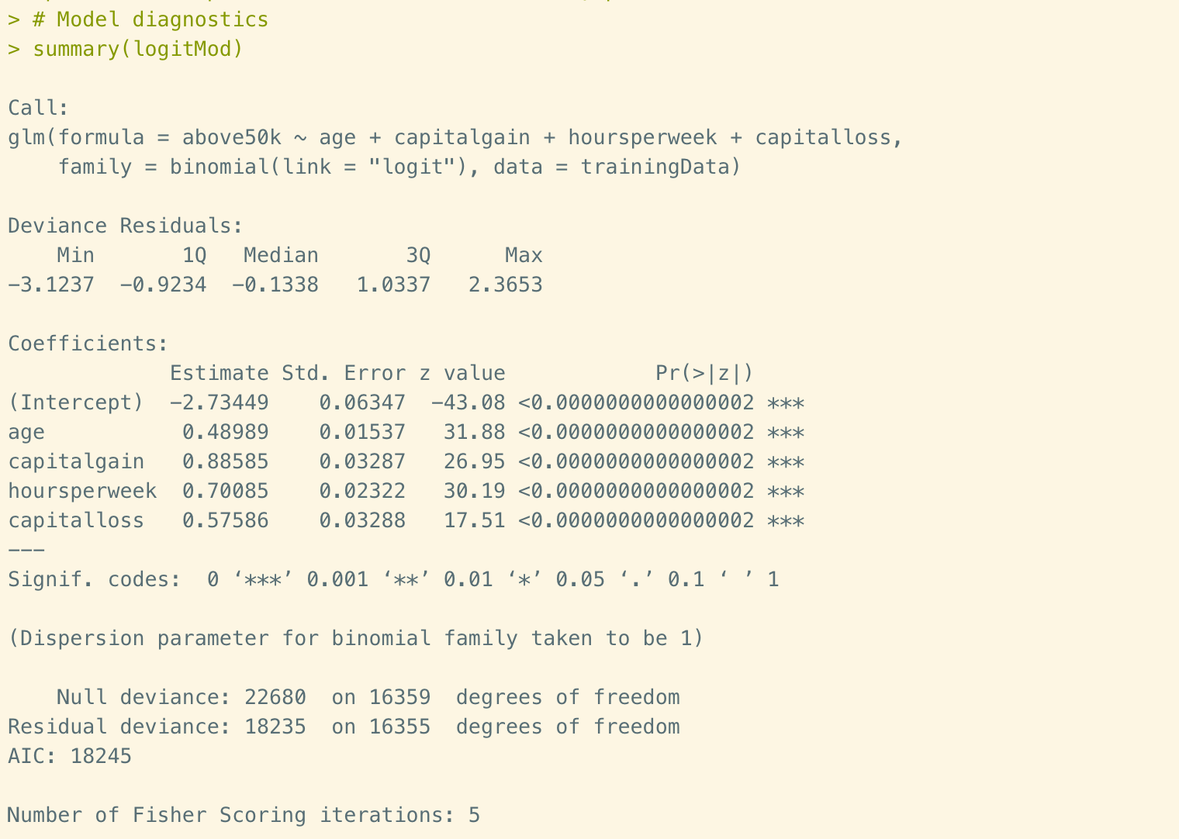
Figure 17. Summary of logitMod
In this summary we could see the call, where R reminding us what we model we ran was logit model. then we could see the deviance residuals, which measures how model fits. Next part is coefficients, their standard errors, the z-statistic, and the associated p-values. In this case, all the p-values are well below 0.05, and thus, all four variables are statistically significant. But a small p-value alone isn’t interesting. We also want large effect sizes. Therefore, we also need to look at the estimate value. To be specific, for every one-unit change in capital gain, the income level of 50k increases by 0.886. For every one-unit change in hours per week, the income level of 50k increases by 0.701. the std error and z value shows the Wald’s test was computed for both coefficients.

VIF
Secondly, let’s take a look at VIF.

Figure 18. VIF
The purpose of VIF is to check for multicollinearity in the model. As we could see from above calculation, all variables in the model have VIF well below 4.

Misclassification Error
Thirdly, let’s find out the Misclassification error.
Figure 19. Misclassification error
This is straightforward value to check. It is the percentage of mismatching the predicted value and actual values. In this case, it is 0.0938. So, the accurate rate is over 90%, which could be well accepted.

ROC
The next index that we are going to check is ROC.
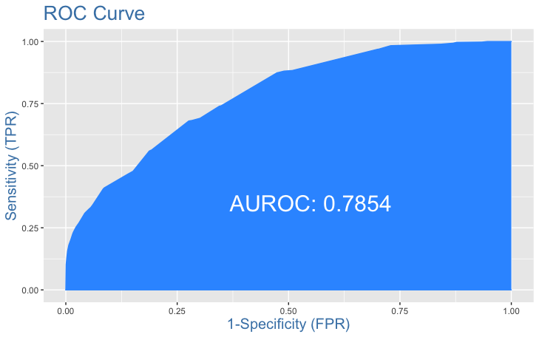
Figure 20. ROC Curve
This is an index to check whether we’ve got an ideal prediction probability cutoff score. For a good model, the cutoff rise steeply. It indicates y-axis increases sharply when x-axis decreases. In our case, the AUROC value is 0.7854, which is acceptable.

Concordance
The concordance value could be calculated in following code.
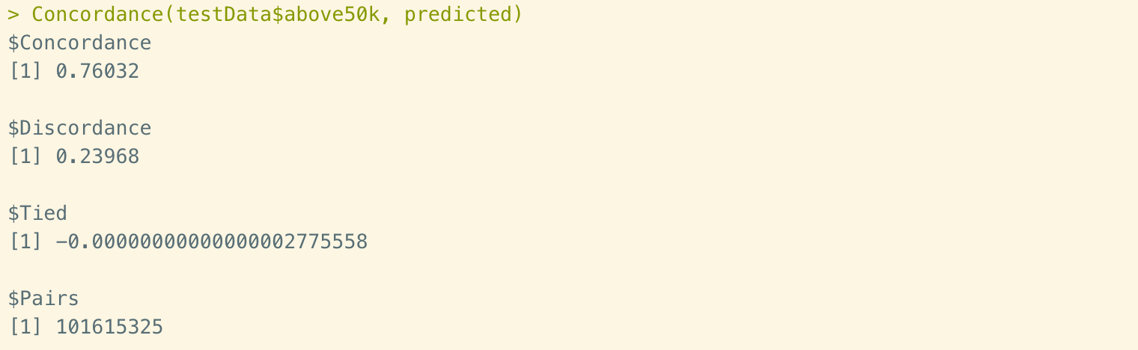
Figure 21. Concordance
The concordance is a measurement of model-calculated-probability scores of all Positive’s are greater than that of Negative’s. The discordance rate would provide the same logic idea. A highly reliable model would have high value of concordance. In this case, the value is 76.032%.

Specificity and Sensitivity
Sensitivity is the percentage of how many 1’s is correctly predicted. Specificity is the percentage of 0’s correctly prediction.
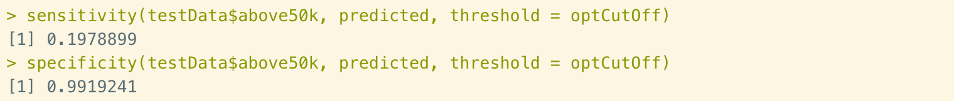
Figure 22. Sensitivity and Specificity
In our case, the specificity is pretty high. But the sensitivity is as low as 0.198. This indicates that only 19.8% 1’s is correctly predicted.

Confusion Matrix
Lastly, let’s drag out the confusion matrix.
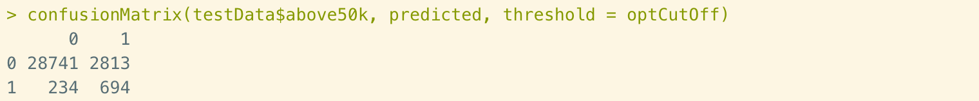
Figure 23. Confusion Matrix
In this matrix we could get a similar idea of what we’ve got from the previous index. The accuracy of predicting 0’s is very high. But most of 1’s is not correctly predicted.

Conclusions
In this report, we practiced Logistic regression in two different data set. In the first one, we have generated an original model, then updated 3 times to find the reliable one. The second data set we have done many preparations work then employed logistic regression model to it. Then we use 7 different ways to evaluate the model.

Reference
- Strickland J. (July 2015). Chapter 11: Generalized linear model. In Predictive Analytics using R (pp. 219-224). Colorado Springs, CO: Simulation Educators.
- Prabhakaran, S. (n.d.). Logistic Regression. R-statistics.co. http://r-statistics.co/Logistic-Regression-With-R.html.

